1. Deploy a Kubernetes cluster on upcloud

Example setting:  
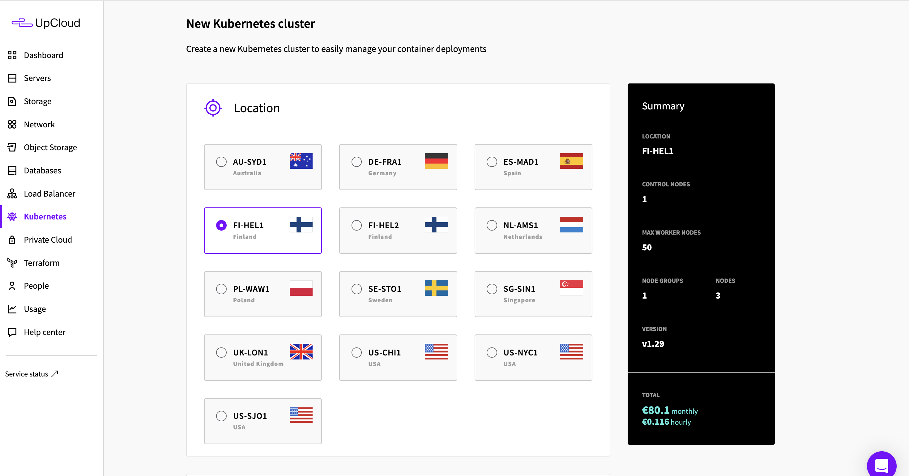

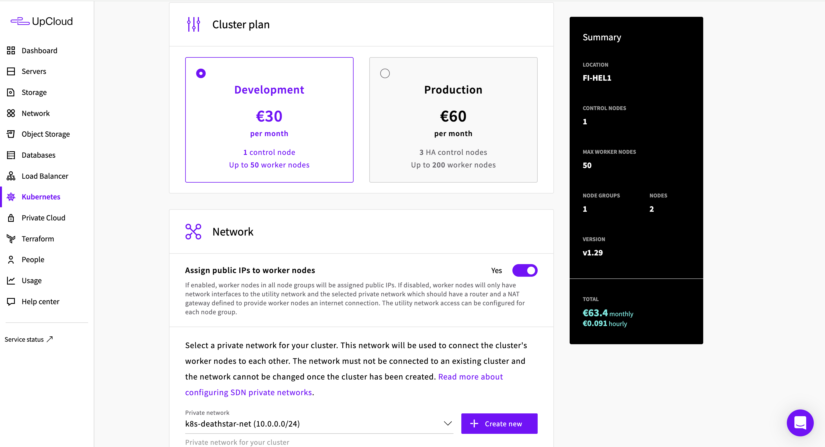

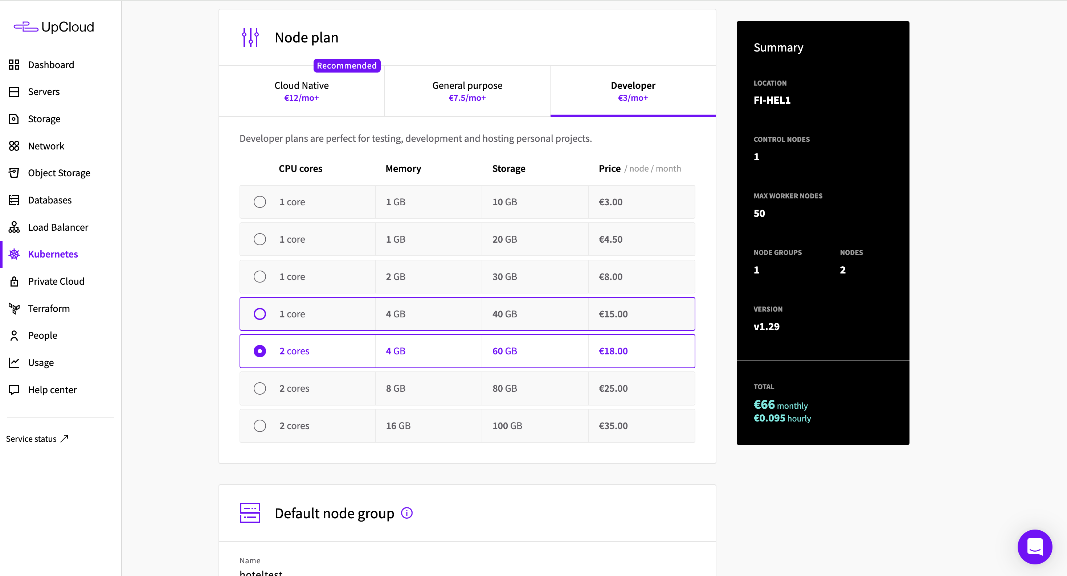

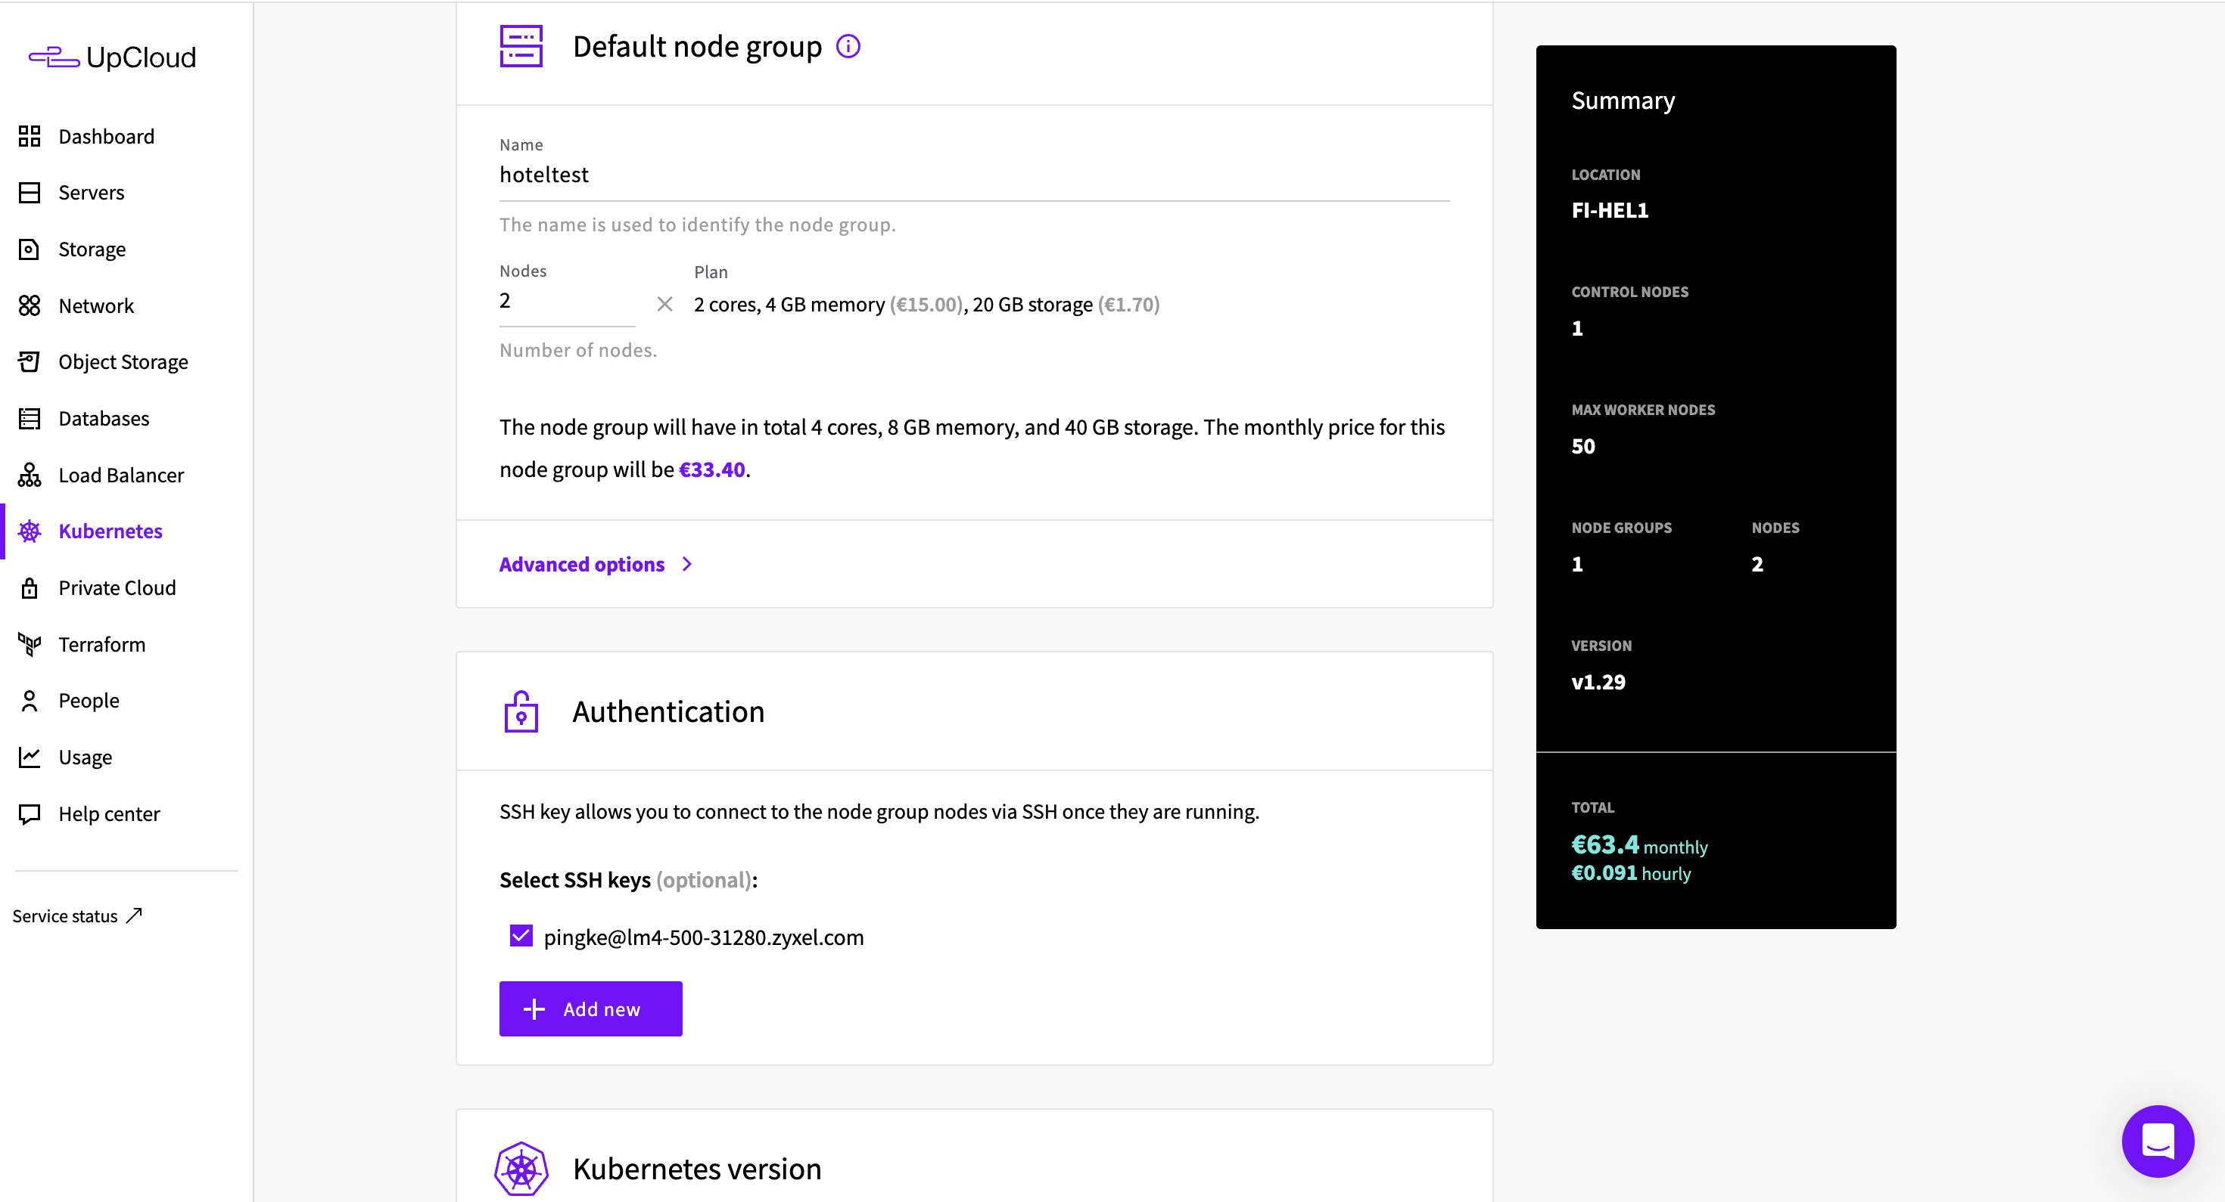

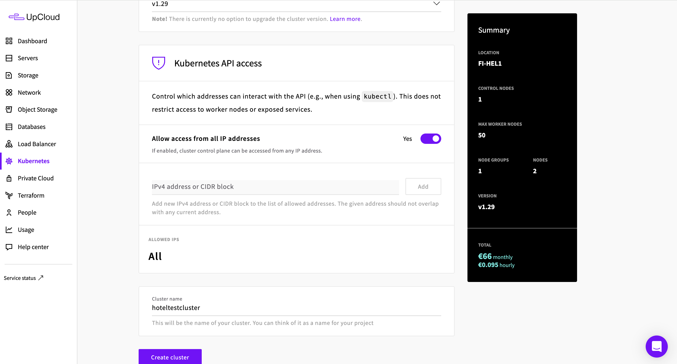

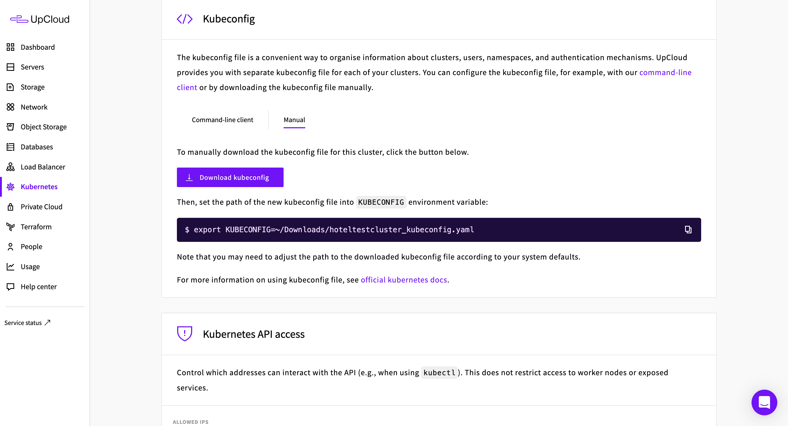

Localhost. Install kubectl needs to be installed in advance: https://kubernetes.io/docs/tasks/tools/install-kubectl-linux/

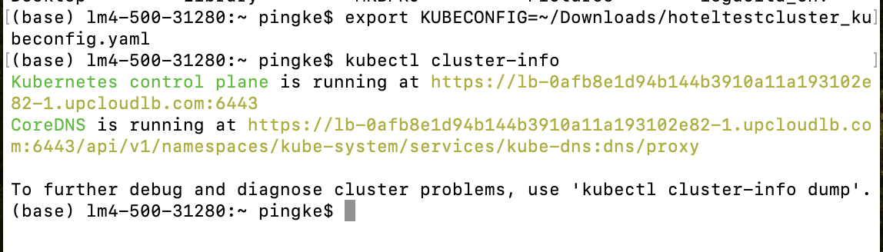

export KUBECONFIG=~/upcloud_test_hotel/student-hotel-test_kubeconfig.yaml

kubectl cluster-info

1. Deploy hotelReservation microservice system on upcloud

Official address:

<https://github.com/delimitrou/DeathStarBench/tree/master/hotelReservation>

Git Clone https://github.com/delimitrou/DeathStarBench.git



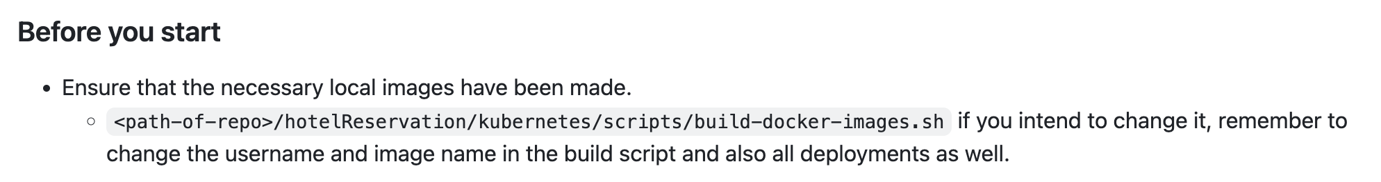

Deploy services

kubectl apply -Rf <path-of repo>/hotelReservation/kubernetes/

kubectl get pods

Potential problem:  
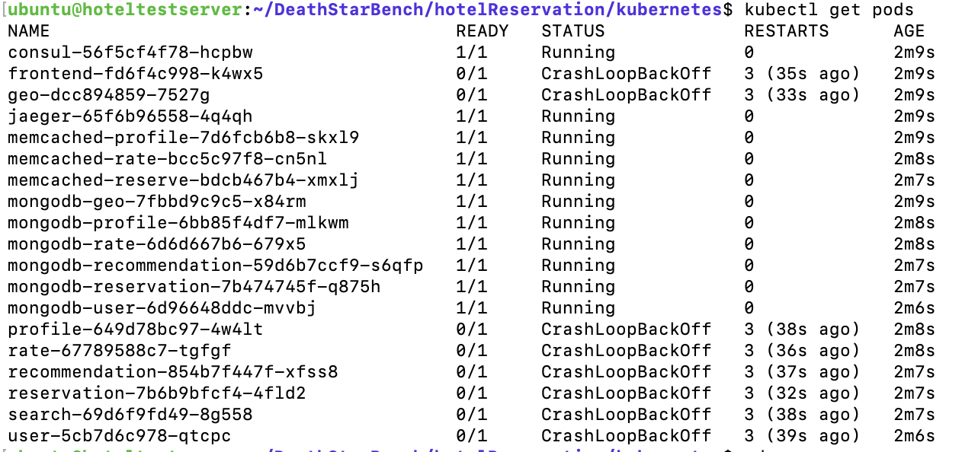

Reason:

Container startup command in the (services)-deployment.yaml file is ./(service), which results in a "file not found" error.

For example

1. “frontend” crashed change file  
   DeathStarBench/hotelReservation/kubernetes/frontend/frontend-deployment.yaml
2. “geo” crashed change file  
   DeathStarBench/hotelReservation/kubernetes/frontend/geo-deployment.yaml
3. “user” crashed

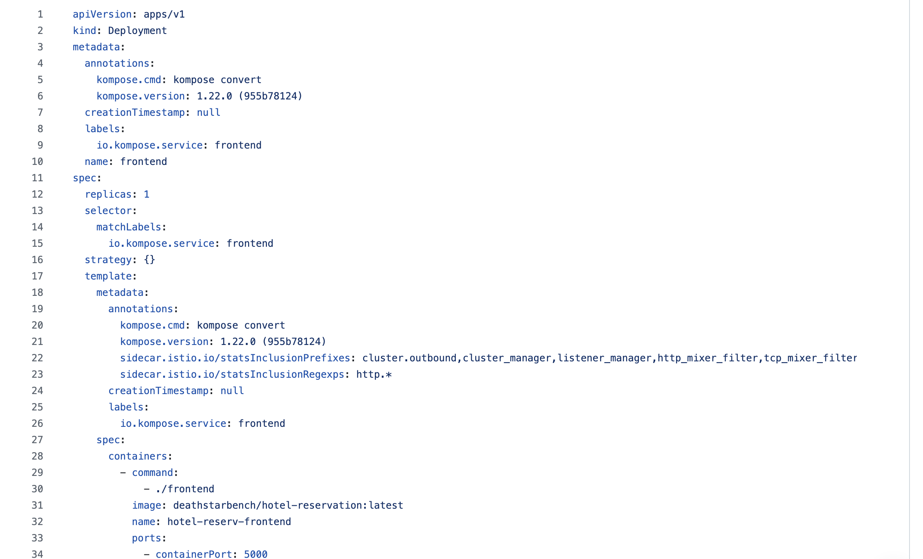

The Go-compiled executable files are located in the GOPATH/bin directory, which in UPCLOUD case is /go/bin. Therefore, You need to change ./(service) to /go/bin/(service).  
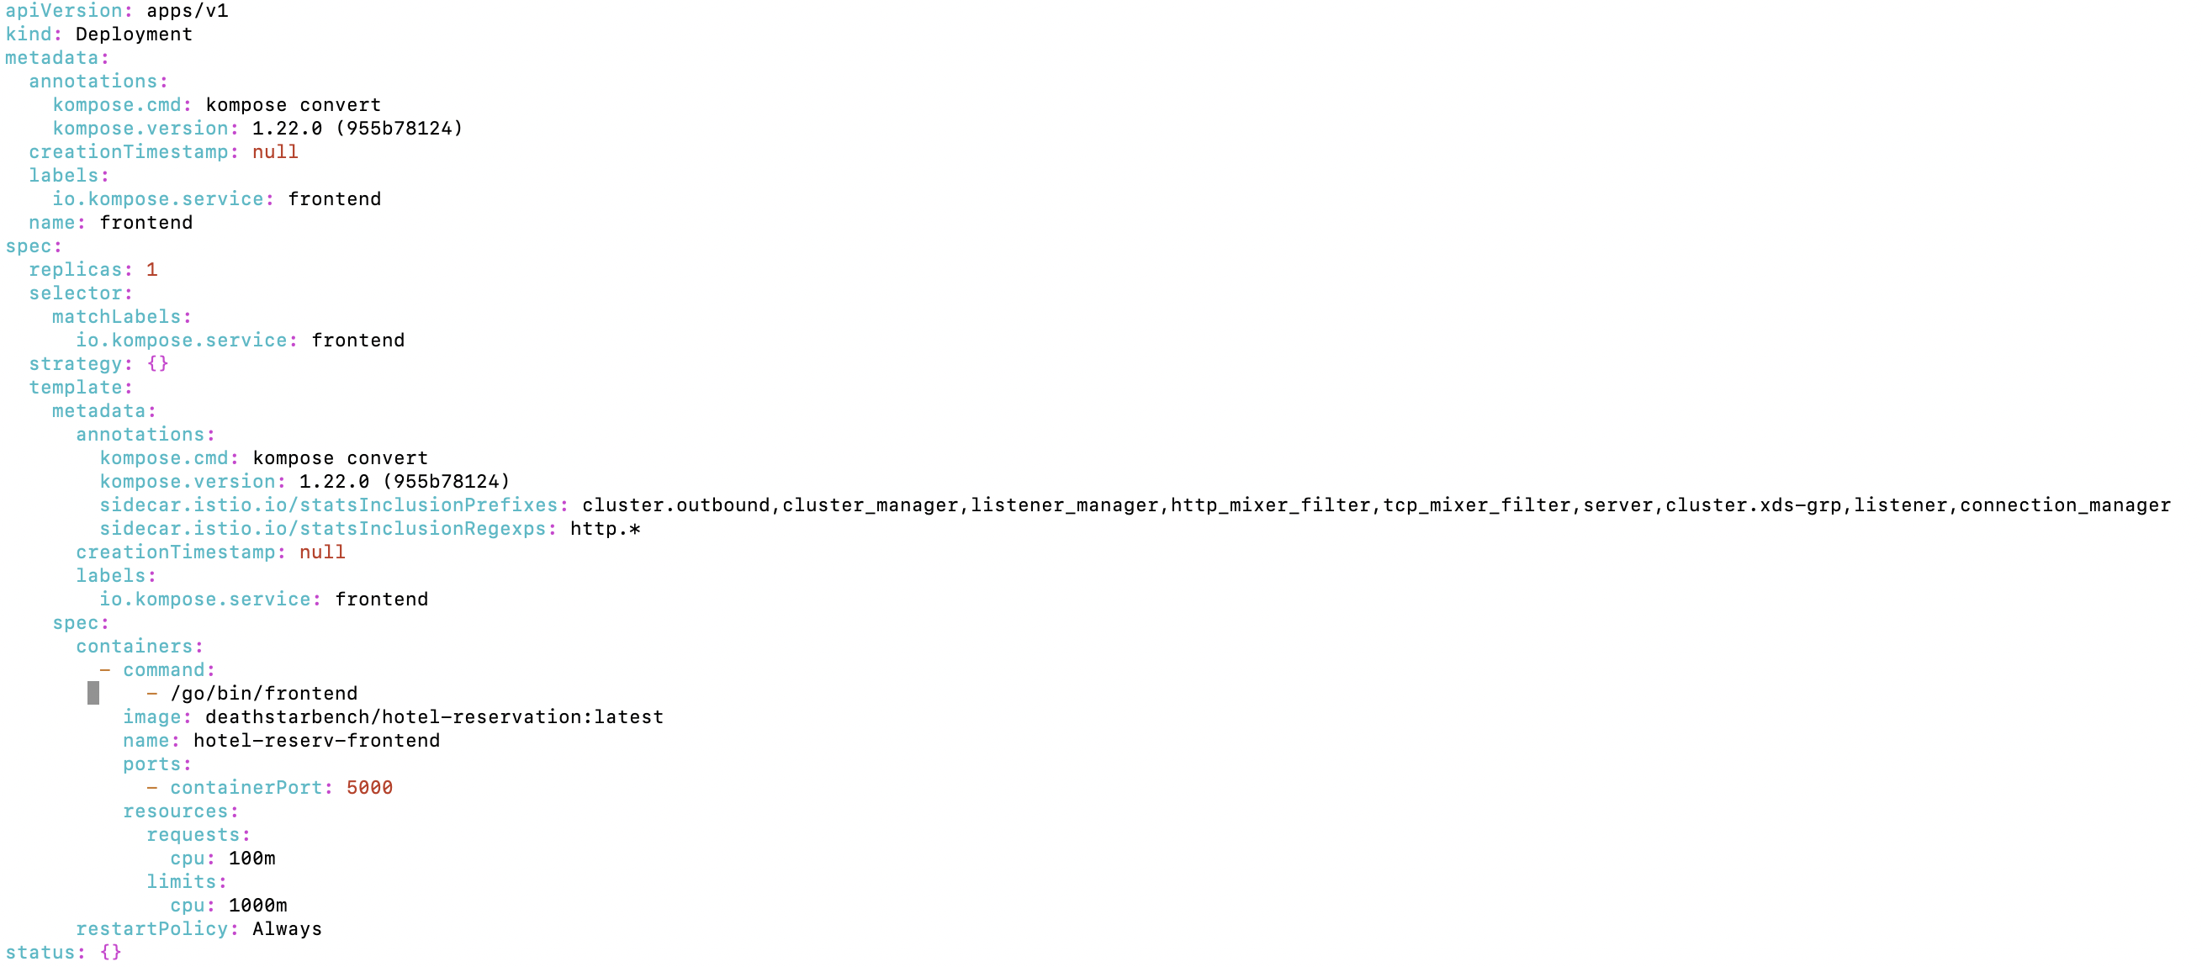

Then

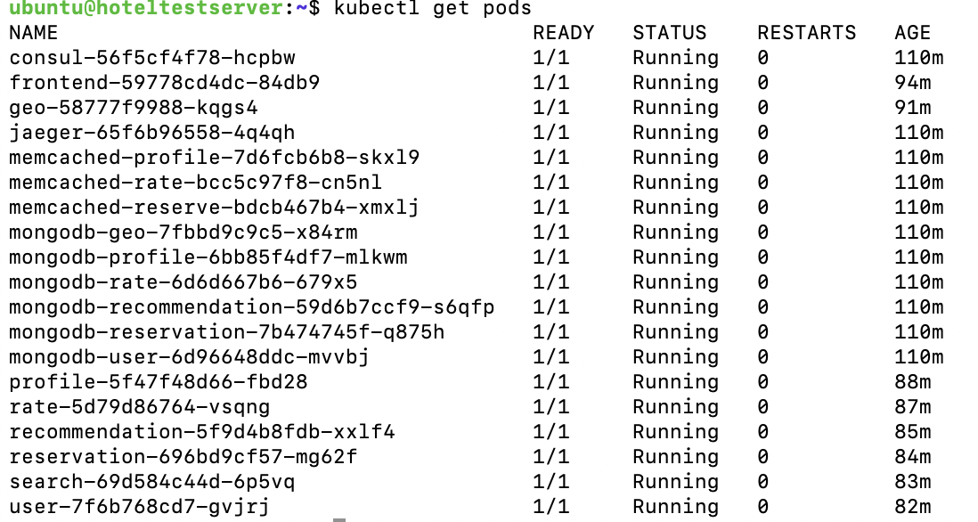

1. Locust test

Install locust

First install python and virtual environment manager anaconda. You can check if you already have these by typing.

conda -V

If you need to install type follow instructions from <https://docs.anaconda.com/anaconda/install/>

After virtual environment setup create new

conda create --name hotel python=3.11

conda activate hotel

Install locous

conda install -c conda-forge locust

OR

pip3 install locust

export PATH=$PATH:$HOME/.local/bin

Official HTTP workload test:

hotelReservation/wrk2/scripts/hotel-reservation/mixed-workload_type_1.lua

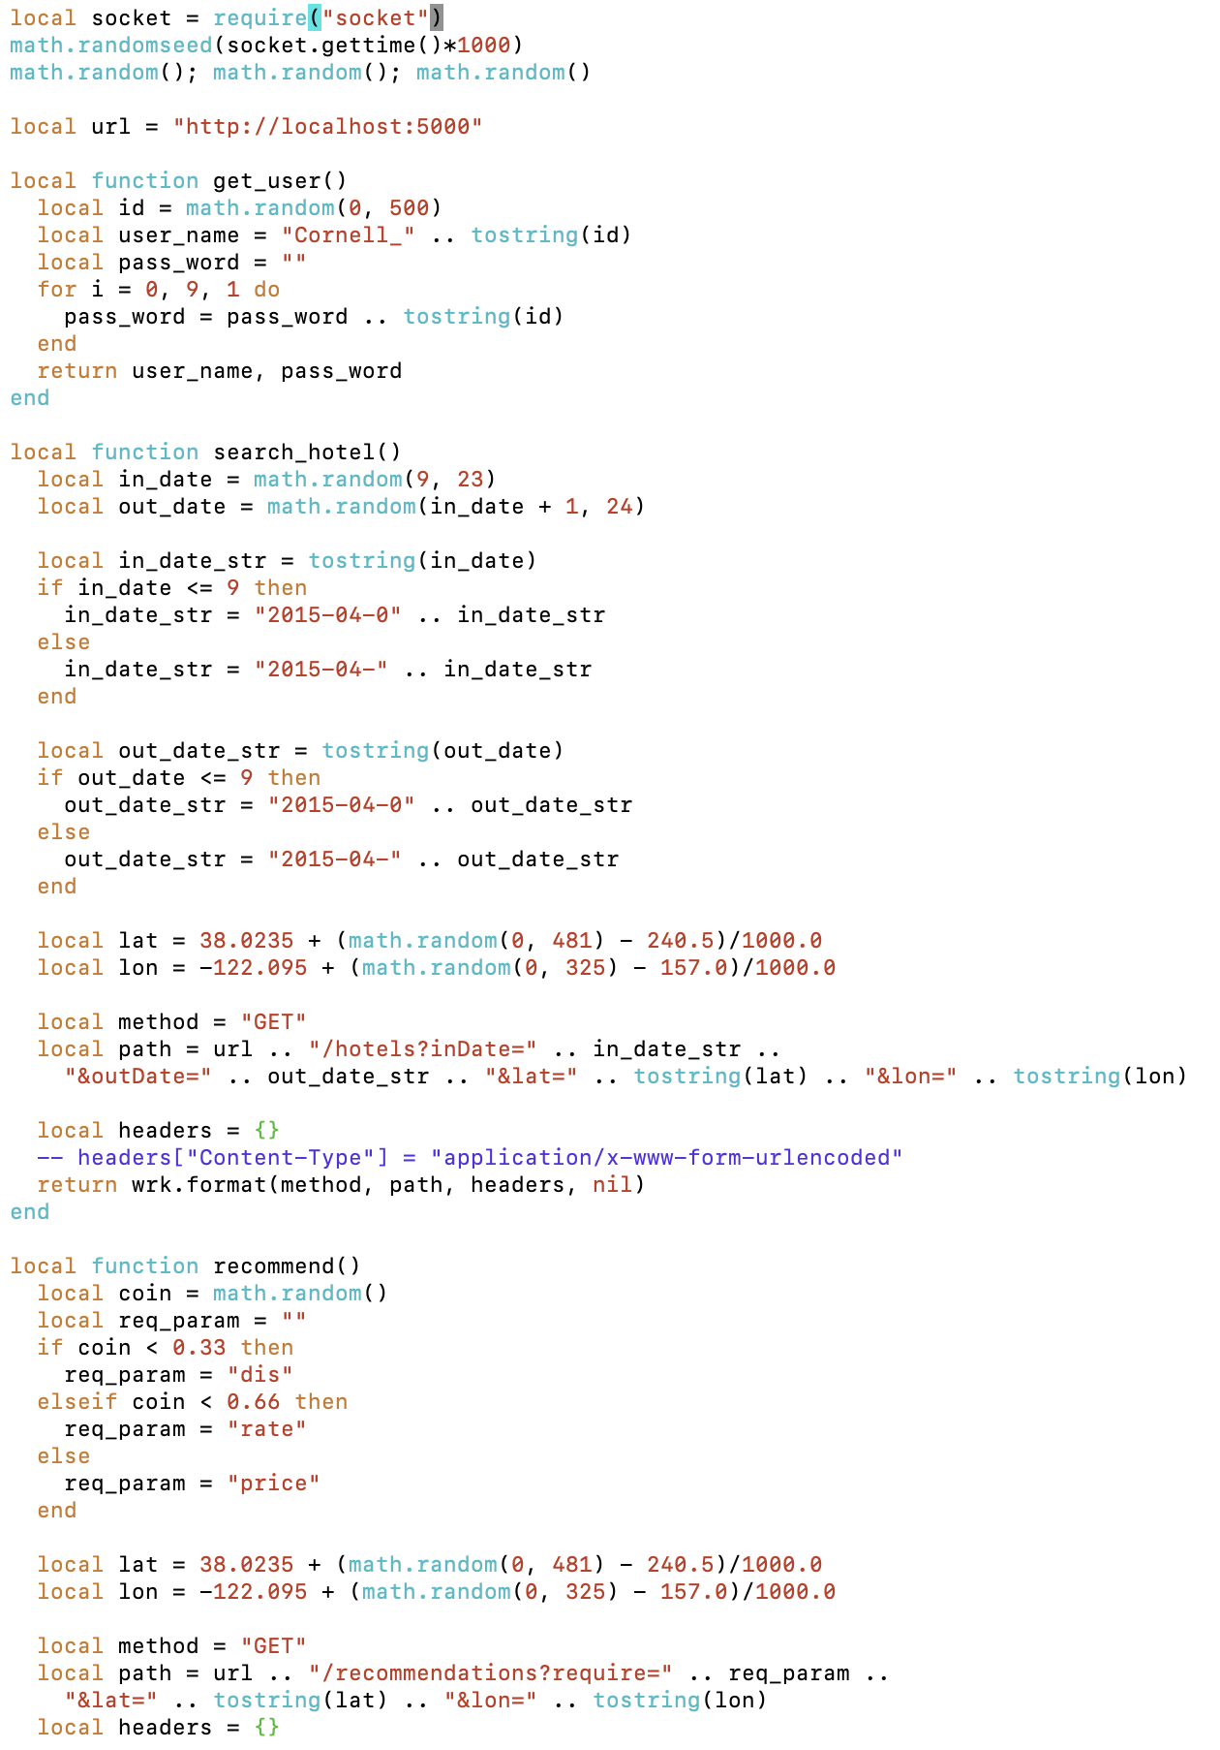

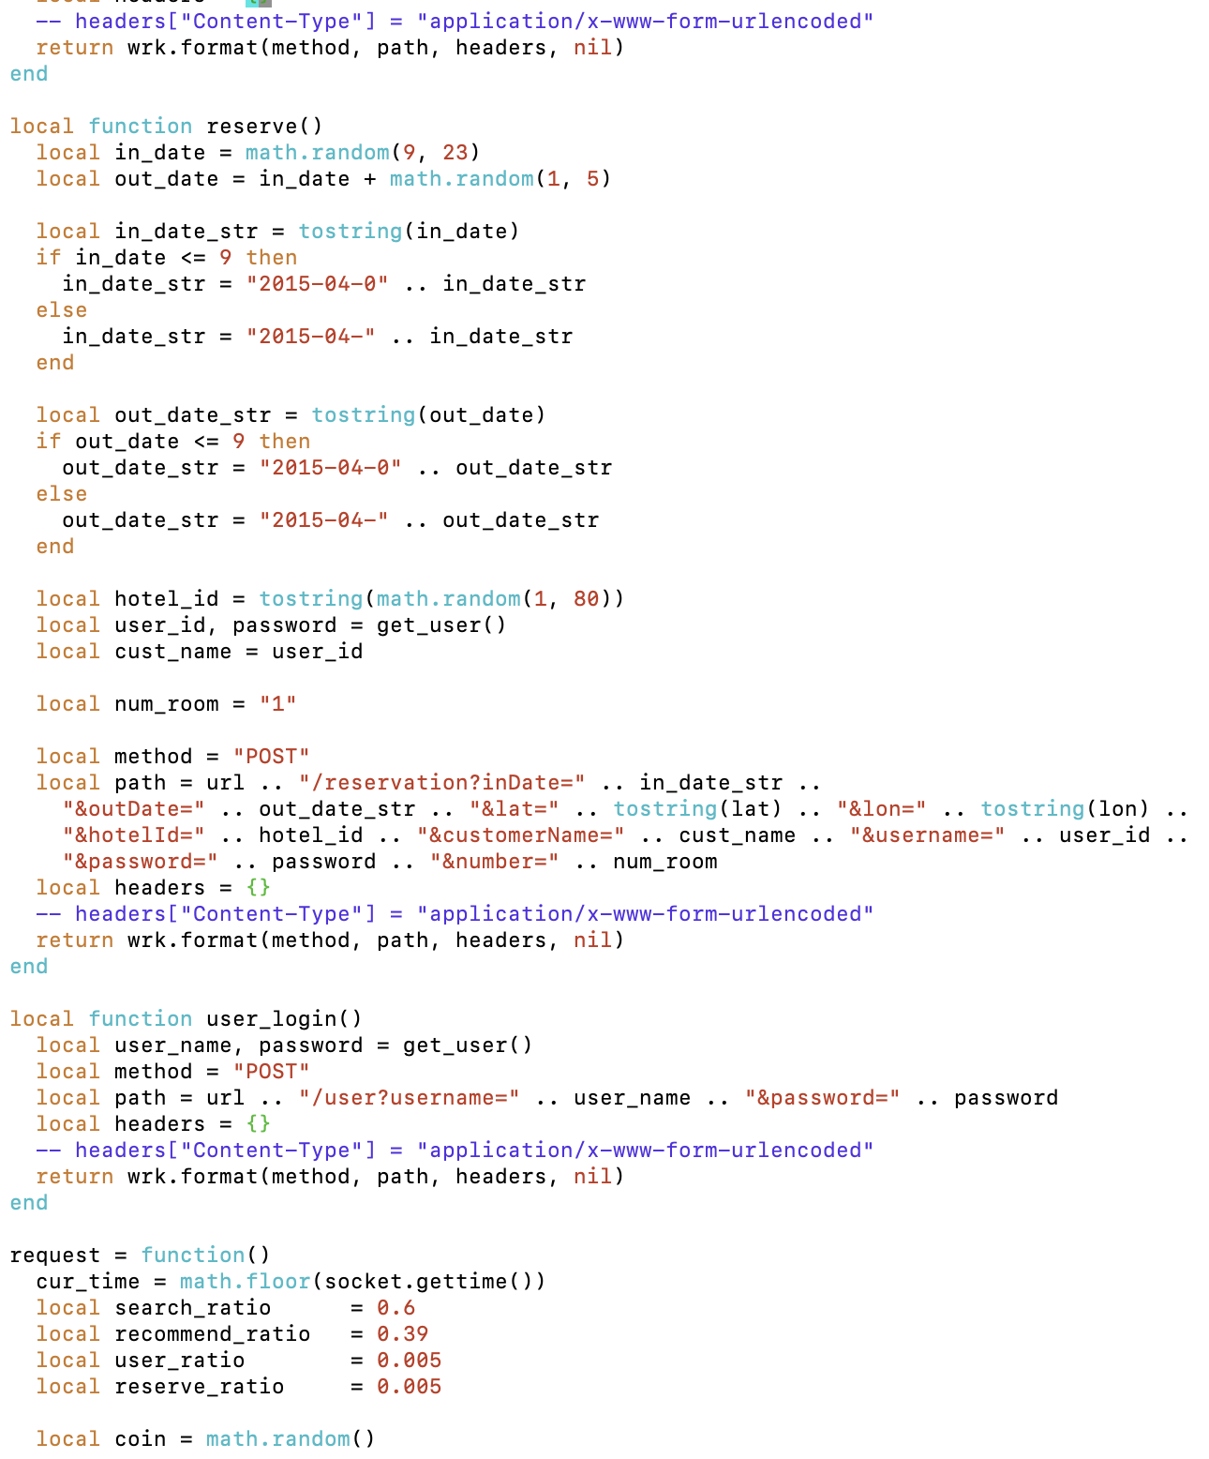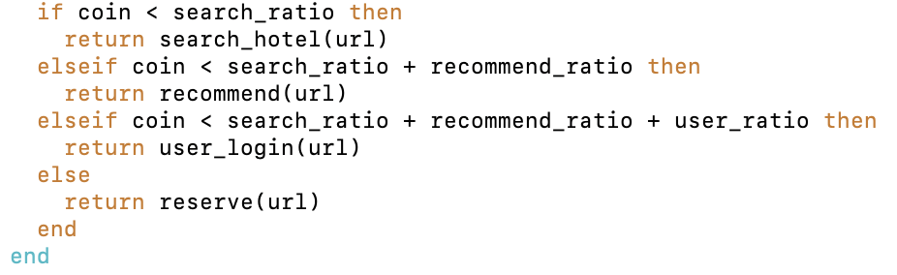

Base on this official workload test, modify to locust test:  
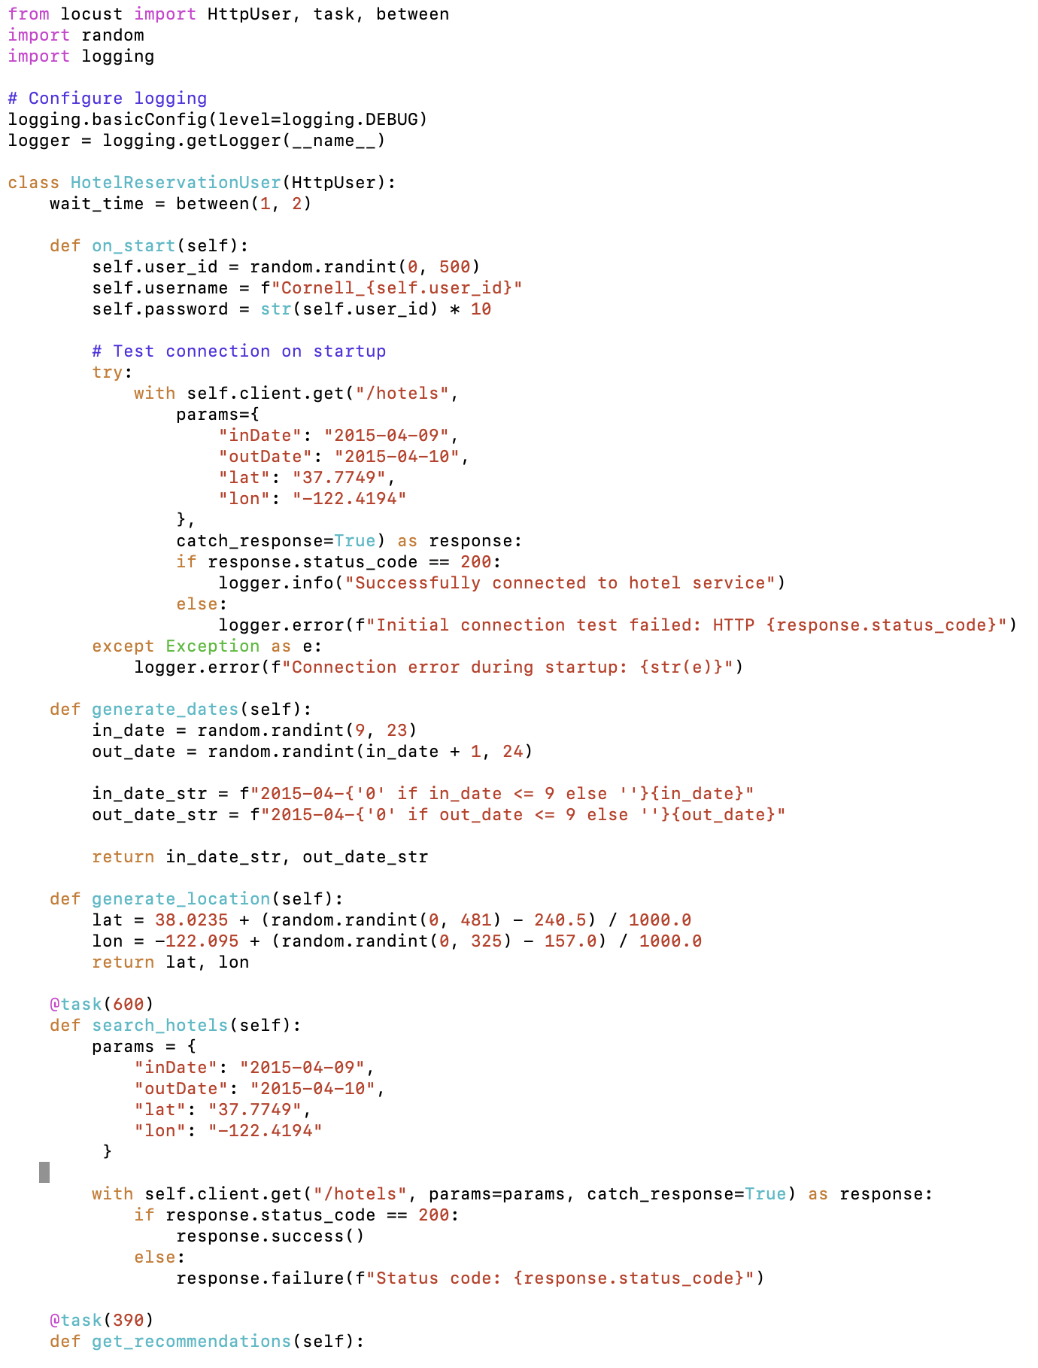

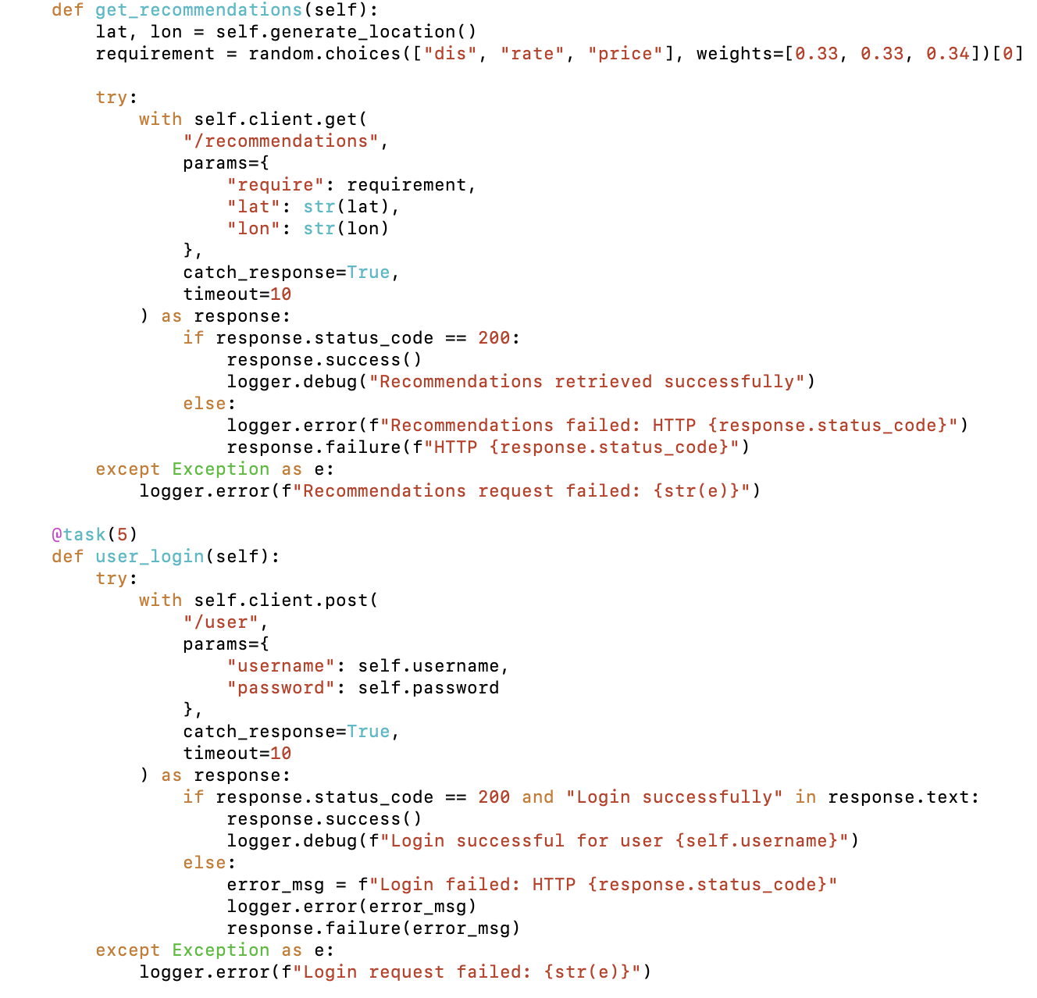

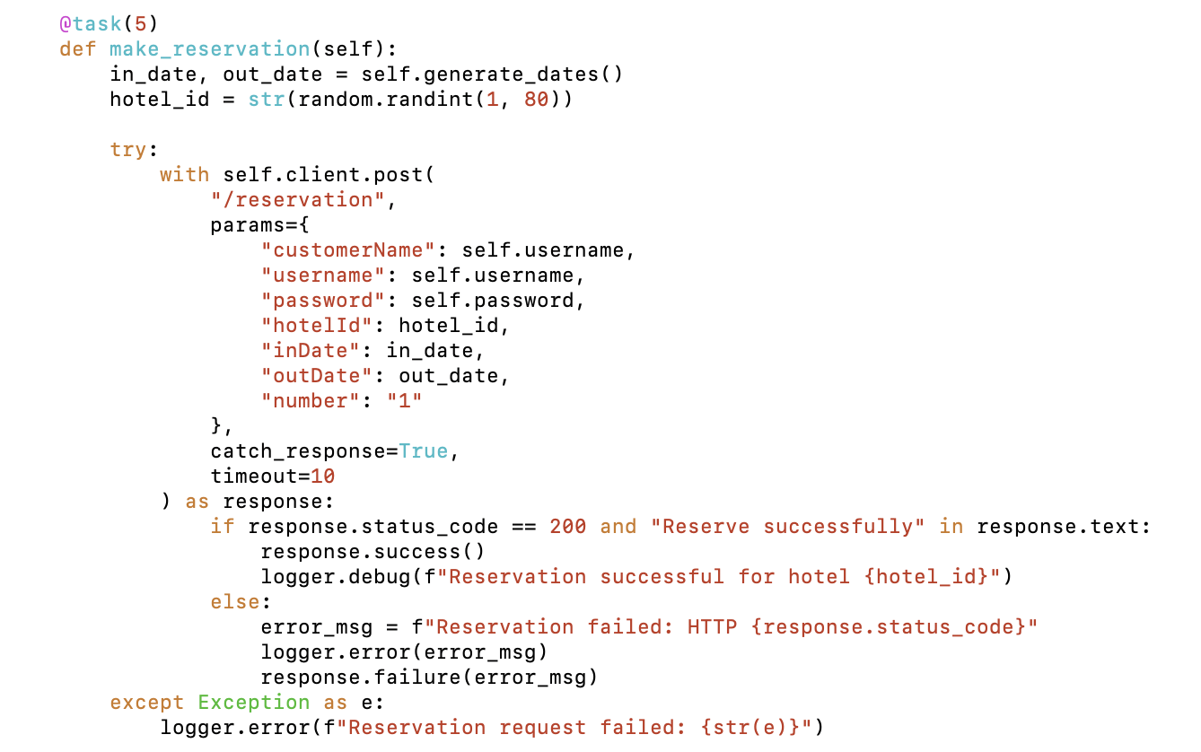

If testing from outside of the cluster, need to convert the frontend service type to LoadBalancer:  
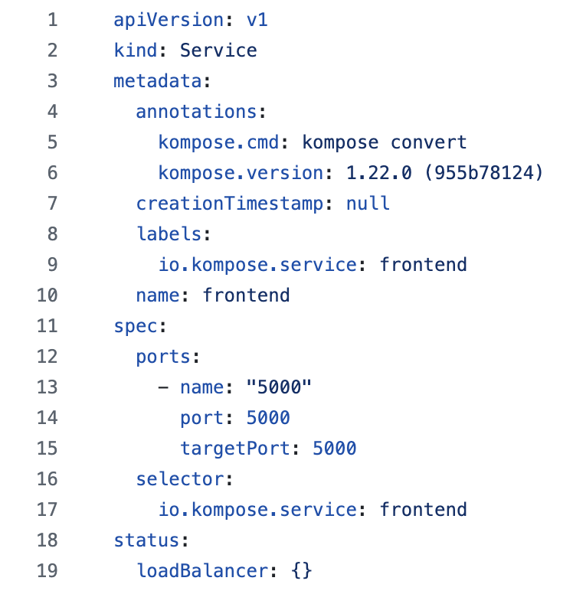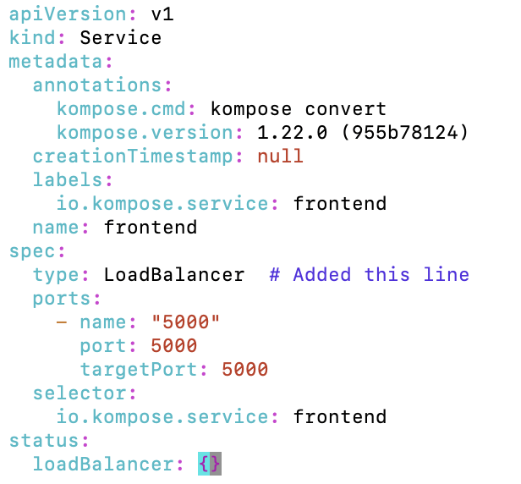

Apply the changes:

kubectl apply -f frontend-service.yaml

OR depending on your location

kubectl apply -f DeathStarBench/hotelReservation/kubernetes/frontend/frontend-service.yaml

Watch for the external-IP to appear it might say pending for while:

kubectl get svc frontend

Or if you like the terminal to wait

kubectl get svc frontend -w  


Executing the test:

Remember to change ip

locust -f <locust test file> --host=http://lb-0aeeabe392334179af9abaa0fe2b6bd1-1.upcloudlb.com:5000 --headless -u 10 -r 2 -t 10s

(parameter description:--host means the address of host; --headless means not start the graphical interface and output the result in terminal;- u means the number of concurrent users; - r means the number of new users per second; -t means the duration of the test)

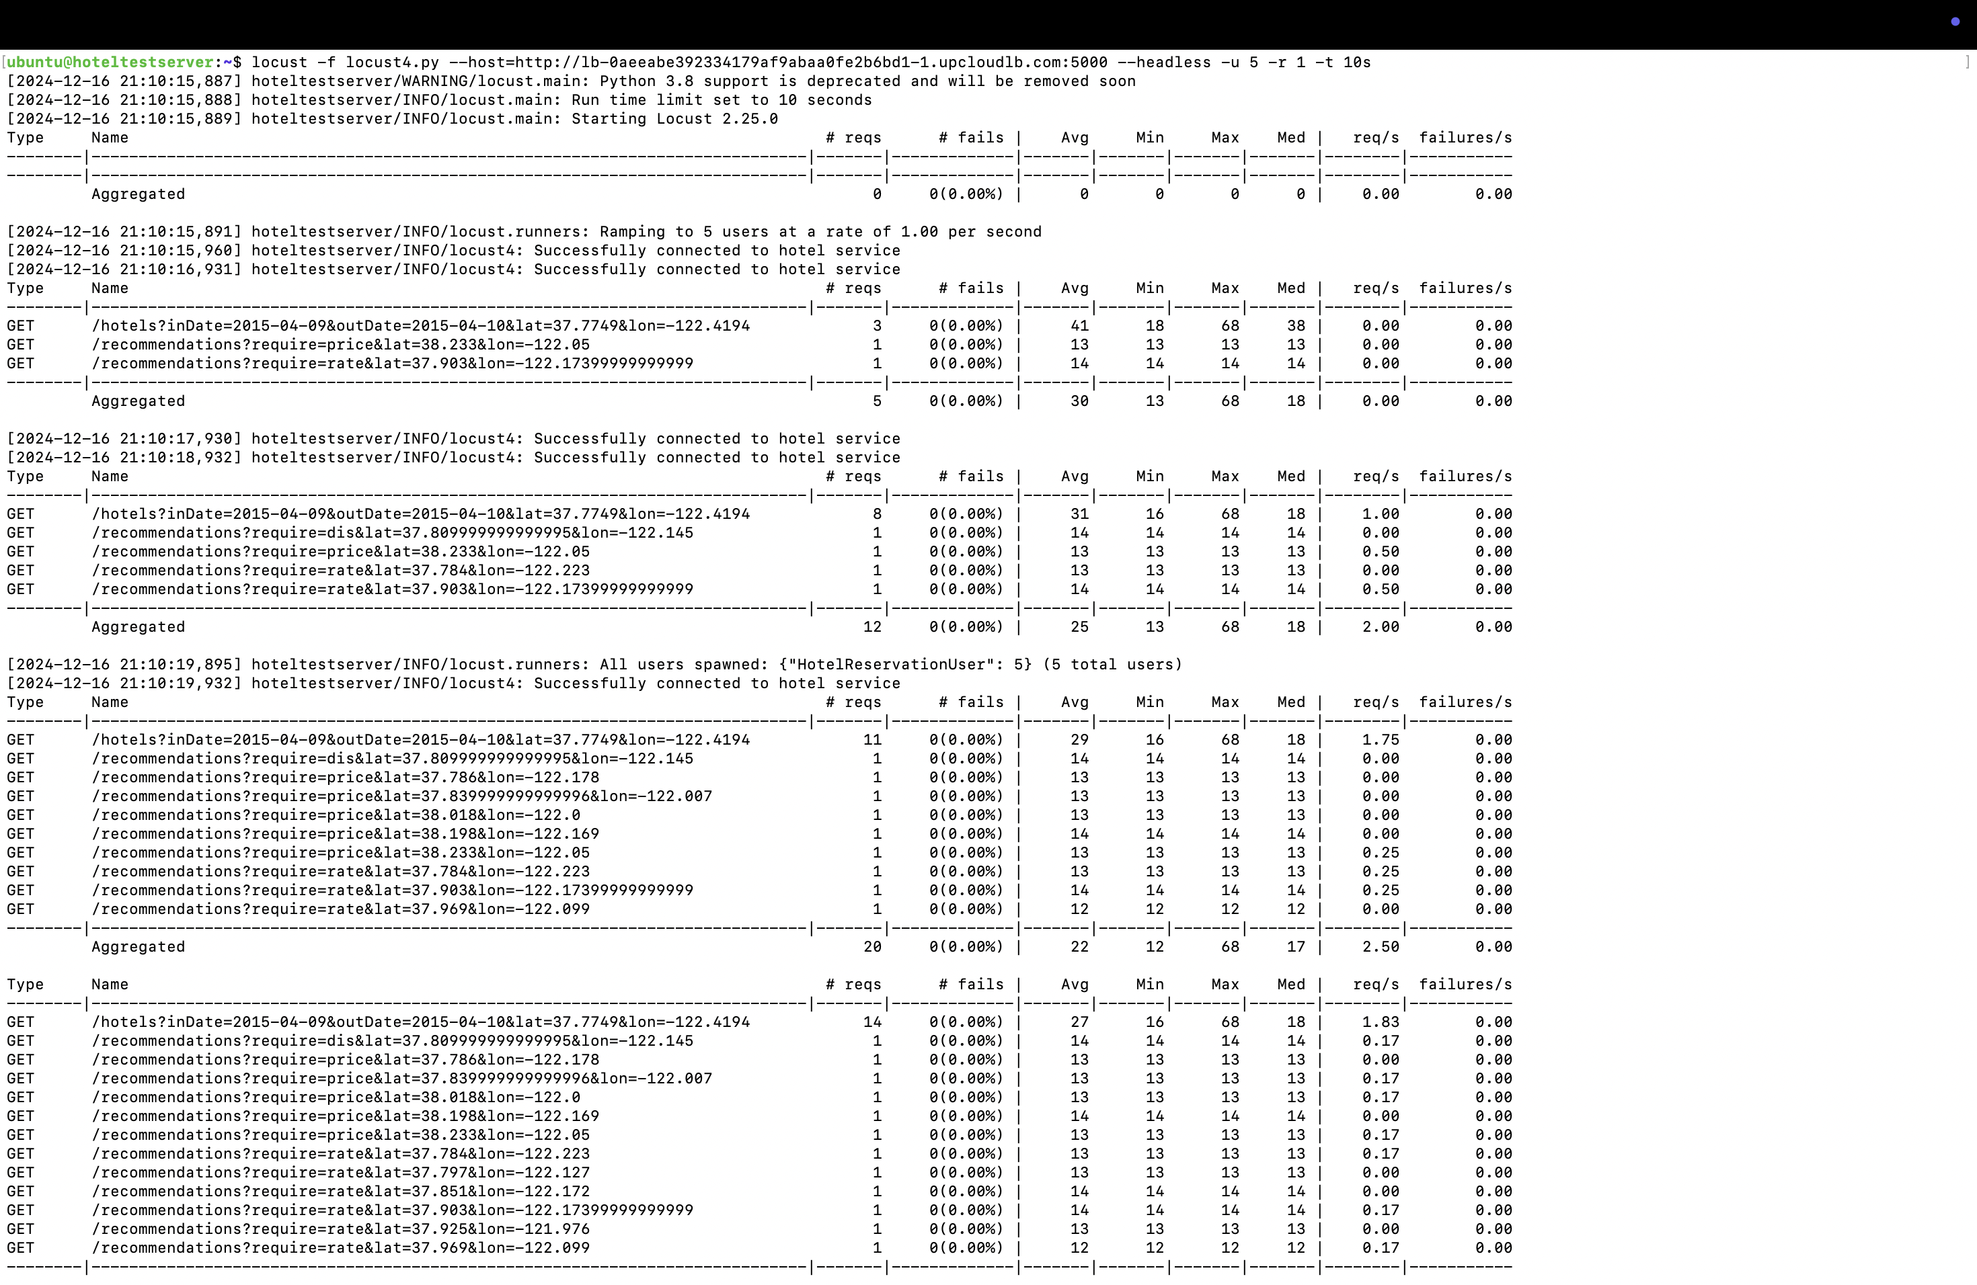

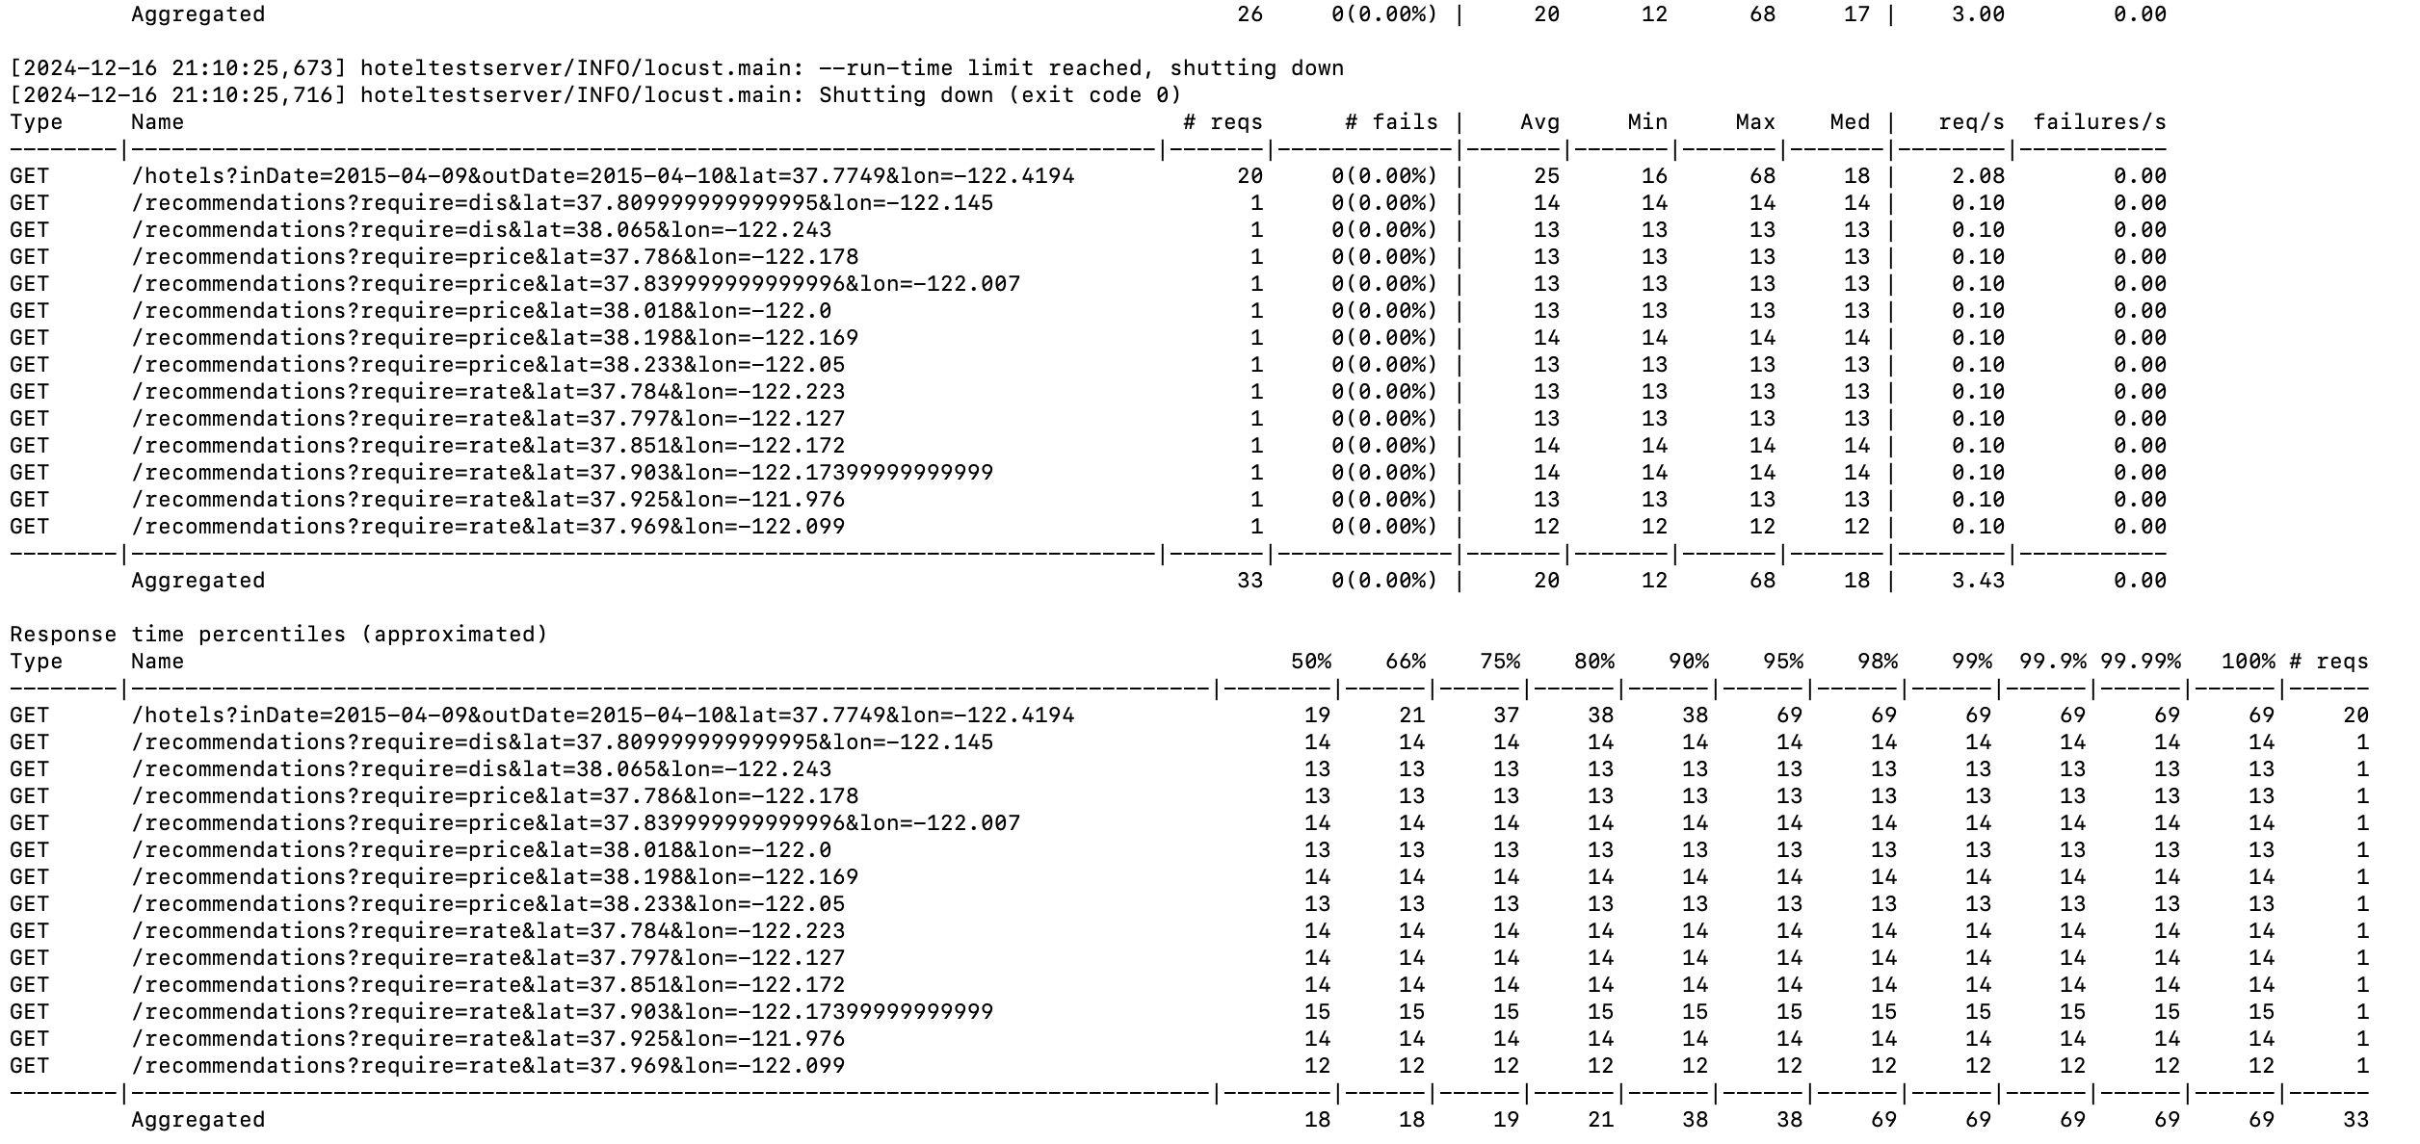

Potential Error:  
  
Reason:  
The cluster configuration is too limited  


Solution:  
improve the number of nodes or CPU or memory

Reduce the number of concurrent users and new users per second

MIKA I got this when running

[2024-12-18 07:51:34,831] lh3-523-29052/WARNING/locust.main: System open file limit '1024 is below minimum setting '10000'.

It's not high enough for load testing, and the OS didn't allow locust to increase it by itself.

See https://github.com/locustio/locust/wiki/Installation#increasing-maximum-number-of-open-files-limit for more info.

